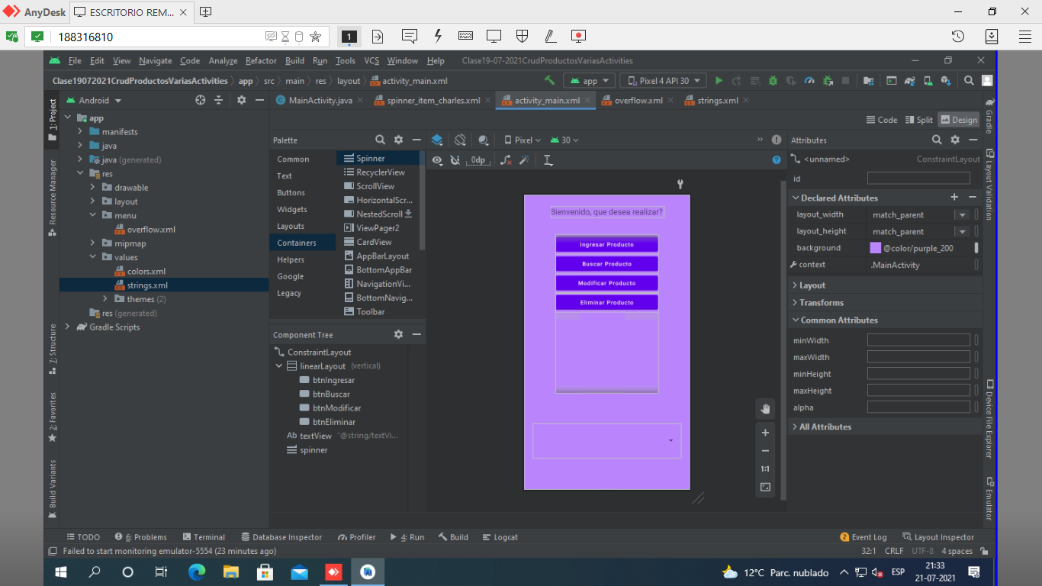
//CODIGO
package com.example.clase19_07_2021crudproductosvariasactivities;

import androidx.appcompat.app.AppCompatActivity;

import android.content.Intent;
import android.database.Cursor;
import android.database.sqlite.SQLiteDatabase;
import android.os.Bundle;
import android.view.Menu;
import android.view.MenuItem;
import android.view.View;
import android.widget.ArrayAdapter;
import android.widget.Spinner;

import java.util.ArrayList;

public class MainActivity extends AppCompatActivity {

private Spinner spinner;
private ArrayList<Producto>lista = new ArrayList<>();
private ArrayList<String> listaFinal = new ArrayList<>();

@Override
protected void onCreate(Bundle savedInstanceState) {
super.onCreate(savedInstanceState);
setContentView(R.layout.activity_main);

spinner = findViewById(R.id.spinner);

llenarSpinner();
}

public void ingresarProducto(View view){
Intent intent = new Intent(this, ActivityIngresarProducto.class);
startActivity(intent);
}

public void buscarProducto(View view){
Intent intent = new Intent(this, ActivityBuscarProducto.class);
startActivity(intent);
}

public void modificarProducto(View view){
Intent intent = new Intent(this, ActivityModificarProducto.class);
startActivity(intent);
}

public void eliminarProducto(View view){
Intent intent = new Intent(this, ActivityEliminarProducto.class);
startActivity(intent);
}

public void llenarSpinner(){

Admindb admin = new Admindb(this, "Productos", null, 1);
SQLiteDatabase base = admin.getWritableDatabase();

Cursor fila = base.rawQuery("select * from producto", null);

while(fila.moveToNext()){
lista.add(new Producto(fila.getInt(0), fila.getString(1), fila.getInt(2)));
}

for(int i = 0; i < lista.size(); i++){

int codigo = lista.get(i).getCodigo();
String nombre = lista.get(i).getNombre();
int precio = lista.get(i).getPrecio();

listaFinal.add(codigo + " - " + nombre + " - " + precio);
}

base.close();

ArrayAdapter<String> adaptador = new ArrayAdapter<>(this, R.layout.spinner_item_charles, listaFinal);
spinner.setAdapter(adaptador);
}

public boolean onCreateOptionsMenu(Menu menu){

getMenuInflater().inflate(R.menu.overflow, menu);

return true;
}

public boolean onOptionsItemSelected(MenuItem item){

int id = item.getItemId();

if(id == R.id.item1){

}

return true;
}
}

